PHARMACOLOGY OF HYPOGLYCEMIC AGENTS.
BY DR. NDERITU ARTHUR

Definition.
- What is Diabetes Mellitus (DM)?
- Diabetes mellitus is a chronic metabolic disorder characterised by a high blood glucose concentration-hyperglycaemia (fasting plasma glucose > 7.0 mmol/l, or plasma glucose > 11.1 mmol/l 2 hours after a meal)-caused by insulin deficiency, often combined with insulin resistance.
- This insufficient insulin results in high blood sugar which affects other metabolic processes in the body.
Classification.
Two main types:-
- Type 1 (IDDM)
- Type 2(NIDDM) or MODM
- Type I diabetes mellitus is also called insulin dependent diabetes mellitus (IDDM), or juvenile onset diabetes mellitus.
- It is an autoimmune disease in which the pancreas produces no insulin at all.
- The patient relies on insulin medication for survival.
- Type I diabetes tends to occur in young, lean individuals, usually before 30 years of age.
- Approximately 10% of the patients with diabetes mellitus have IDDM.
- Type II diabetes mellitus is also referred to as non-insulin dependent diabetes mellitus (NIDDM), or adult onset diabetes mellitus (AODM).
- It is a metabolic disorder resulting from the body's inability to make enough, or properly use, insulin.
- 90% of all Diabetes Mellitus are of Type II. Type II diabetes mellitus occurs mostly in individuals over 40 years old.
- The incidence of type II diabetes increases with age.
- Unlike type I diabetes mellitus, 80% of type II diabetic patients are obese. Type II diabetes mellitus also has a strong genetic tendency.
- Gestational Diabetes Mellitus (GDM).

Clinical features of Diabetes Mellitus.
- Symptoms of NIDDM.
The early symptoms of untreated diabetes mellitus are related to elevated blood sugar levels, and excretion of it to the urine.
- High amounts of glucose in the urine can cause increased urine output (polyuria) and lead to dehydration.
- Dehydration causes increased thirst and water consumption (polydipsia).
- Because of the inability of the cells to take up glucose, the patient always feels hungry and eats a lot (polyphagia) compounding the high sugars.
- Some untreated diabetic patients also complain of fatigue, nausea, and vomiting due to ketones.
- Patients with diabetes are prone to developing infections of the bladder, skin, and vaginal areas as the high sugars provide an optimum environment for bacteria growth.
- Fluctuations in blood glucose levels can lead to blurred vision.
- Extremely elevated glucose levels can lead to lethargy and coma (diabetic coma).

Diagnosis: The diagnosis of Type 2 Diabetes is made if:
- Fasting (no caloric intake for 8 hours) blood sugar is ≥126mg/dL (7.0 mmol/L) on two occasions.
- Random blood sugar is ≥200mg/dL (11.1 mmol/dL) with symptoms of polyuria, polydipsia, visual blurring, etc.
- HbA1c ≥ 6.5%
- Oral glucose tolerance test (OGTT): 2 hours post prandial (75 gm of glucose given). ≥200mg/dL (11.1 mmol/L)

Treatment:
- Initial therapy should include lifestyle modification.
1. Dietary control of diabetes comes down a few simple principles:
a. Eat less (fewer calories) to maintain ideal body weight.
b. Eat low glycaemic index foods that do not turn into sugar quickly.
c. Refrain from excessive protein in your diet.
d. Split your menu into 6 small meals per day, rather than the traditional 3 square meals.

- Regular exercise and weight reduction to a BMI of <25 kg/m2.

While most people think of exercise as a way to reduce body weight (especially since 80% of diabetes are obese), exercise does much more, including reducing insulin resistance and impotence.

- Smoking cessation and reduction of alcohol consumption.

Glycemic control for all patients utilizes HbA1c and not RBS. A target HbA1c for all patients is <8% after 3-6 months of therapy without hypoglycemia.

Combinations of oral medications and/or insulin to achieve this goal will likely be necessary.

INSULIN
INSULIN SYNTHESIS
Like other peptide hormones, insulin is synthesised as a precursor (preproinsulin) in the rough endoplasmic reticulum. Preproinsulin is transported to the Golgi apparatus, where it undergoes proteolytic cleavage first to proinsulin and then to insulin plus a fragment of uncertain function called C-peptide. Insulin and C-peptide are stored in granules in B cells, and are normally cosecreted by exocytosis in equimolar amounts together with smaller and variable amounts of proinsulin. The main factor controlling the synthesis and secretion of insulin is the blood glucose concentration . B cells respond both to the absolute glucose concentration and to the rate of change of blood glucose. Other stimuli to insulin release include amino acids (particularly arginine and leucine), fatty acids, the parasympathetic nervous system, peptide hormones for the gut and drugs that act on sulfonylurea receptors.

ATP-sensitive potassium channels determine the resting membrane potential in B cells. Glucose enters B cells via a membrane transporter called Glut-2, and its subsequent metabolism via glucokinase (the rate-limiting enzyme that acts as the 'glucose sensor' linking insulin secretion to extracellular glucose) and glycolysis increases intracellular ATP. This blocks K_{ATP} channels, causing membrane depolarisation and opening of voltage-dependent calcium channels, leading to Ca²⁺ influx. The resulting increase in cytoplasmic Ca²⁺ triggers insulin secretion

- Many gastrointestinal hormones influence insulin secretion, including gastrin, secretin, cholecystokinin, gastric inhibitory polypeptide (GIP), glucagon-like peptide (GLP) and GLP₁ (the amide of a fragment of GLP), all of which stimulate insulin secretion. They are released by eating. This explains why oral glucose causes greater insulin release than does the same amount of glucose administered intravenously. These hormones (in particular GIP and GLP₁) provide an anticipatory signal from the gastrointestinal tract to the islets, and offer some novel prospects for treating diabetes.
- The GLP1 is rapidly inactivated. Continuous infusion improves diabetic control but is impractical for routine use. Alternative strategies include the use of stable analogues such as exenatide, a GLP₁ agonist that was recently approved in the USA, or of drugs that antagonise the dipeptidase enzyme (DPP-IV) that inactivates GLP1.
- Insulin release is inhibited by the sympathetic nervous system. Adrenaline (epinephrine) increases blood glucose by inhibiting insulin release (via α₂ adrenoceptors) and by promoting glycogenolysis via β₂ adrenoceptors in striated muscle and liver. Several peptides, including somatostatin, galanin (an endogenous K_{ATP} activator) and amylin, also inhibit insulin release.
Effects of insulin on carbohydrate, fat and protein metabolism

Type of metabolism | Liver cells | Fat cells | Muscle
Carbohydrate metabolism | ↓Gluconeogenesis | ↑Glucose uptake | ↑Glucose uptake
 | ↓Glycogenolysis | ↑Glycerol synthesis | ↑Glycolysis
 | ↑Glycolysis |  | ↑Glycogenesis
 | ↑Glycogenesis
Fat metabolism | ↑Lipogenesis | ↑Synthesis of triglycerides | -
 | ↓Lipolysis | ↑Fatty acid synthesis
 |  | ↓Lipolysis
Protein metabolism | ↓Protein breakdown | - | ↑Amino acid uptake
 |  |  | ↑Protein synthesis

Insulin therapy

All diabetic patients will eventually need insulin due to the progressive loss of pancreas function.
MOA of Insulin
Insulin lowers blood glucose by stimulating peripheral glucose uptake, especially by skeletal muscles and fat and by inhibiting hepatic glucose production (decreases gluconeogenesis and glycogenolysis). Insulin also inhibits lipolysis and proteolysis and enhances protein synthesis. Targets include skeletal muscle, liver and adipose tissue.
Injection technique for insulin: injection sites include abdomen, arm, hip and thigh.
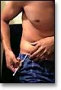

The following chart lists the types of injectable insulin with details about onset (the length of time before insulin reaches the bloodstream and begins to lower blood sugar), peak (the time period when the insulin is the most effective in lowering blood sugar) and duration (how long insulin continues to lower blood sugar). These three factors may vary, depending on your body's response. The final column provides some insight into the "coverage" provided by the different insulin types in relation to mealtime.

Type of Insulin & Brand Names | Onset | Peak | Duration | Role in Blood Sugar Management
Rapid-Acting
Humalog or lispro | 15-30 min. | 30-90 min | 3-5 hours | Rapid-acting insulin covers insulin needs for meals eaten at the same time as the injection. This type of insulin is used with longer-acting insulin.
Novolog or aspart | 10-20 min. | 40-50 min. | 3-5 hours
Apidra or glulisine | 20-30 min. | 30-90 min. | 1-2½ hours
Short-Acting
Regular (R) humulin or novolin | 30 min. -1 hour | 2-5 hours | 5-8 hours | Short-acting insulin covers insulin needs for meals eaten within 30-60 minutes
Velosulin (for use in the insulin pump) | 30 min.-1 hour | 2-3 hours | 2-3 hours
Intermediate-Acting
NPH (N) | 1-2 hours | 4-12 hours | 18-24 hours | Intermediate-acting insulin covers insulin needs for about half the day or overnight. This type of insulin is often combined with rapid- or short-acting insulin.
Lente (L) | 1-2½ hours | 3-10 hours | 18-24 hours
Long-Acting
Ultralente (U) | 30 min.-3 hours | 10-20 hours | 20-36 hours | Long-acting insulin covers insulin needs for about one full day. This type of insulin is often combined, when needed, with rapid- or short-acting insulin.
Lantus / insulin glargine | 1-1½ hour | No peak time; insulin is delivered at a steady level | 20-24 hours
Levemir or detemir | 1-2 hours | 6-8 hours | Up to 24 hours
Pre-Mixed*
Humulin 70/30 | 30 min. | 2-4 hours | 14-24 hours | These products are generally taken twice a day before mealtime.
Novolin 70/30 | 30 min. | 2-12 hours | Up to 24 hours
Novolog 70/30 | 10-20 min. | 1-4 hours | Up to 24 hours
Humulin 50/50 | 30 min. | 2-5 hours | 18-24 hours
Humalog mix 75/25 | 15 min. | 30 min.-2½ hours | 16-20 hours
*Premixed insulins are a combination of specific proportions of intermediate-acting and short-acting insulin in one bottle or insulin pen (the numbers following the brand name indicate the percentage of each type of insulin).

Dosage is individualized and determined by the physician in accordance with the needs of the patient.
The average range of total daily insulin requirement for maintenance therapy in type 1 diabetes lies between 0.5 and 1.0 IU/kg/day. However, in pre-pubertal children it usually varies from 0.7 to 1.0 IU/kg/day, but can be much lower during the period of partial remission. In insulin resistance, (e.g., during puberty or due to obesity) the daily insulin requirement may be substantially higher.
Initial dosages for type 2 diabetes are often lower, e.g., 0.3 to 0.6 IU/kg/day. This should be adjusted slowly until optimum glycaemic control is reached. The total daily insulin requirement for maintenance therapy in type 2 diabetes is usually higher than the initial dose.

Adverse Effects of Insulin
  - Hypoglycemia
  - Hypersensitivity reaction
  - Local irritation at site of injection
  - Lypodystrophy
  - Hypokalemia

Contraindications and precautions of Insulin
- Hypoglycaemia
- Hypersensitivity to human insulin or any of the excipients
- Insulin suspensions should not be administered intravenously
- Insulin suspensions should not be added to infusion fluids.
- Insulin suspensions are not suitable for the treatment of diabetic ketoacidotic coma
- Human insulin solutions should not be used if they do not appear water-clear and colourless.
- Human insulin suspensions should not be used if they do not appear uniformly white and cloudyafter suspension.

How to store insulin in use:
-Insulin currently in use by the person with diabetes does not need to be stored in the fridge
-An injection of cold insulin will hurt
-Human insulin is stable at 25 °C for 6 weeks and at 37 °C for 4 weeks
-The insulin, however, must be kept away from direct sunlight and be kept in a cool place
-Analogues will maintain stability for 4 weeks at temperatures of 30 °C and lower.
-Re-suspend insulin by rolling the vial gently between the two hands; AVOID vigorous shaking, as this will destroy the insulin molecules
How to store insulin which is not in use:
-Keep insulin in the fridge at 4-8 °C.
-Human insulin is stable for 30 months from the manufacturing date at these temperatures, compared to 24 months for analogues
-Store the insulin in a separate container, at the bottom of the fridge and away from the freezer compartment.
-Do not store insulin in the fridge door, as this will cause exposure to fluctuating temperatures.
-Insulin must not be frozen. This may appear to be perfectly acceptable once it has defrosted, but changes in the crystalline structure cause it’s action profile to be unpredictable.
-The expiry date is printed on each insulin vial, penfill or penset.

TYPES OF ORAL HYPOGLYCEMIC AGENTS.
- INSULIN SECRETAGOGUES: SULFONYLUREAS AND MEGLITINIDES
Eg, (a)Sulfonylureas: First generation: chlorpropamide (250-500mg daily) and tolbutamide.
Second generation: glibenclamide (2.5-10mg daily, max 15mg) (glyburide), glipizide(2.5-5mg daily), glicazide(40-320mg daily (Diamicron MR®(30-120mg daily), and glimepiride (1-4mg daily) (Amaryl®).
(b) Meglitinide analogues eg Repaglinide and retaglinide.

(a) Sulfonylureas:
- These agents are classified as insulin secretagogues because they stimulate insulin release from the β cells of the pancreas.
Mechanism of action:
- Stimulation of insulin release from the β cells of the pancreas by blocking the ATP-dependent K⁺ channels, resulting in depolarization and Ca²⁺ influx.
- They also cause an increase in peripheral insulin sensitivity.
Pharmacokinetics:
- Given orally, these drugs bind to serum proteins
- Metabolized by the liver
- Excreted by the liver or kidney
- Tolbutamide has the shortest duration of action (6-12 hours), whereas the second-generation agents last about 24 hours
Adverse Effects:
- Weight gain
- Hyperinsulinemia
- Hypoglycemia
- These drugs should be used with caution in patients with hepatic or renal insufficiency, because delayed excretion of the drug-resulting in its accumulation-may cause hypoglycemia.
- Renal impairment is a particular problem in the case of those agents that are metabolized to active compounds, such as glyburide.
- Glyburide has minimal transfer across the placenta and may be a reasonably safe alternative to insulin therapy for diabetes in pregnancy.

(b) Meglitinide Analogs
- This class of agents includes repaglinide and nateglinide. Although they are not sulfonylureas, they have common actions.
Mechanism of action:
- Their action is dependent on functioning pancreatic β cells.
- They bind to a distinct site on the sulfonylurea receptor of ATP-sensitive potassium channels, thereby initiating a series of reactions culminating in the release of insulin.
- However, in contrast to the sulfonylureas, the meglitinides have a rapid onset and a short duration of action.
- They are categorized as postprandial glucose regulators.
- Meglitinides should not be used in combination with sulfonylureas due to overlapping mechanisms of action.
Pharmacokinetics:
- These drugs are well absorbed orally after being taken 1 to 30 minutes before meals.
- Both meglitinides are metabolized to inactive products by CYP3A4 in the liver.
- Excreted through the bile.
Adverse Effects:
- Incidence of hypoglycemia is lower than that of the sulfonylureas.
- Repaglinide has been reported to cause severe hypoglycemia in patients who are also taking the lipid-lowering drug gemfibrozil.
- Weight gain is less of a problem with the meglitinides than with the sulfonylureas.
- Must be used with caution in patients with hepatic impairment.
- MEDICATIONS THAT DECREASE HEPATIC GLUCOSE PRODUCTION: BIGUANIDES EG METFORMIN (500tds or 850bd..max 3g daily) (GLUCOPHAGE®).
- Metformin does not alter concentrations of insulin in the blood and, therefore, rarely causes low blood glucose levels. (Euglycemic). Recommended for obese patients.
- It requires insulin for its action, but it does not promote insulin secretion.
- Hyperinsulinemia is not a problem. Thus, the risk of hypoglycemia is far less than that with sulfonylureas.
- Metfromin doesn’t cause weight gain, hence it is ideal for obese patients.
Mechanism of action:
- It causes reduction of hepatic glucose output, largely by inhibiting hepatic gluconeogenesis.
- Improves peripheral glucose uptake and utilization.
- Metformin may be used alone or in combination with one of the other agents, as well as with insulin.
Pharmacokinetics:
- Metformin is well absorbed orally, is not bound to serum proteins
- It is not metabolized by liver
- Excretion is via the urine.

Adverse effects:
- These are largely gastrointestinal.
- Fatal lactic acidosisin elderly patients with end organ failure (liver, cardiac, etc)
- Contraindicated in diabetics with renal and/or hepatic disease, acute myocardial infarction, severe infection, or diabetic ketoacidosis.
- Megaloblastic anemia.
- NB: Metformin, if not contraindicated and if tolerated, is the preferred initial pharmacological agent for type 2 diabetes.

- MEDICATIONS THAT INCREASE THE SENSITIVITY OF CELLS TO INSULIN: THIAZOLIDINEDIONES OR GLITAZOLES.
- Although insulin is required for their action, these drugs do not promote its release from the pancreatic β cells; thus, hyperinsulinemia does not result.
- Troglitazone was the first of these to be approved for the treatment of Type 2 diabetic, but was withdrawn after a number of deaths due to hepatotoxicity were reported. Presently, two members of this class are available, pioglitazone (15-30mg daily) and rosiglitazone (4-8mg daily).
Mechanism of action
- They cause increased insulin sensitivity in adipose tissue, liver, and skeletal muscle.
Pharmacokinetics:
- Both pioglitazone and rosiglitazone are absorbed very well after oral administration and are extensively bound to serum albumin.
- Both undergo extensive metabolism by different cytochrome P450 isozymes.
- Pioglitazone:
- Renal elimination is negligible, with the majority of the active drug and metabolites excreted in the bile and eliminated in the feces.
- Rosiglitazone:
- The metabolites are primarily excreted in the urine.
Adverse Effects:
- Very few cases of liver toxicity have been reported with rosiglitazone or pioglitazone.
- Main disadvantage is weight gain, oedema and risk of CHF, bone fractures, bladder cancer.

- MEDICATIONS THAT DECREASE THE ABSORPTION OF CARBOHYDRATES FROM THE INTESTINE: ALPHA-GLUCOSIDASE INHIBITORS EG ACARBOSE (25-100mg tid) AND MIGLITOL.
- They are oral anti-diabetic drugs used for diabetes mellitus type 2 that work by preventing the digestion of carbohydrates (such as starch and table sugar). Carbohydrates are normally converted into simple sugars (monosaccharides), which can be absorbed through the intestine. Hence, alpha-glucosidase inhibitors reduce the impact of carbohydrates on blood sugar.
Mechanism of action:
- These drugs are taken at the beginning of meals. They act by delaying the digestion of carbohydrates, thereby resulting in lower postprandial glucose levels. Both drugs exert their effects by reversibly inhibiting membrane-bound α-glucosidase in the intestinal brush border. This enzyme is responsible for the hydrolysis of oligosaccharides to glucose and other sugars. Consequently, the postprandial rise of blood glucose is blunted. Unlike the other oral hypoglycemic agents, these drugs do not stimulate insulin release, nor do they increase insulin action in target tissues. Thus, as monotherapy, they do not cause hypoglycemia. However, when used in combination with the sulfonylureas or with insulin, hypoglycemia may develop.
Pharmacokinetics:
- Acarbose is poorly absorbed. It is metabolized primarily by intestinal bacteria, and some of the metabolites are absorbed and excreted into the urine. On the other hand, miglitol is very well absorbed but has no systemic effects. It is excreted unchanged by the kidney.
Adverse effects:
- The major side effects are flatulence, diarrhea, and abdominal cramping. Patients with inflammatory bowel disease, colonic ulceration, or intestinal obstruction should not use these drugs.

- INCRETIN MIMETIC AGENTS

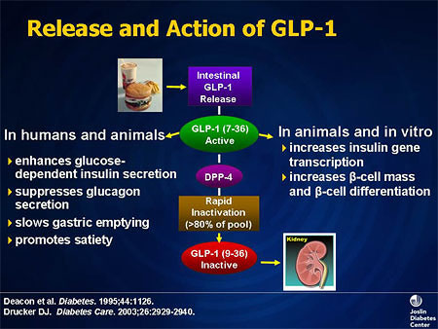

What Is DPP-4?
  - A serine protease widely distributed throughout the body
  - Cleaves N-terminal amino acids of a number of biologically
active peptides, including the incretins Glucagon like peptide 1 (GLP-1) and gastric inhibitory peptide (GIP), resulting in inactivation
  - Its effects on GLP-1 and GIP have been shown to affect incretin activity
  - DPP-4 inactivates GLP-1 >50% in ~1 to 2 minutes.
  - Blocking DPP-4 Can Improve Incretin Activity and Correct the Insulin:Glucagon Ratio in T2DM.

- Dipeptidyl peptidase-4 inhibitors (DDP-4 inhibitors)

- DPP-4 inhibitors or gliptins, are a class of oral hypoglycemics that block DPP-4. They can be used to treat diabetes mellitus type 2.
- The first agent of the class was Sitagliptin (50-100mg daily). Others are: Saxagliptin (2.5-5mg daily), vidagliptin (50mg od or bd daily).
- Glucagon increases blood glucose levels, and DPP-4 inhibitors reduce glucagon and blood glucose levels. The mechanism of DPP-4 inhibitors is to increase incretin levels (Glucagon like peptide 1; GLP-1 and Gastric inhibitory Peptide; GIP), which inhibit glucagon release, which in turn increases insulin secretion, decreases gastric emptying, and decreases blood glucose levels.

Mechanism of action:
- Sitagliptin inhibits the enzyme DPP-IV, which is responsible for the inactivation of incretin hormones, such as glucagon-like peptide-1 (GLP-1). Prolonging the activity of incretin hormones results in increased insulin release in response to meals and a reduction in inappropriate secretion of glucagon. Sitagliptin may be used as monotherapy or in combination with a sulfonylurea, metformin or a glitazone.

Pharmacokinetics:
- Sitagliptin is well absorbed after oral administration. Food does not affect the extent of absorption. The majority of sitagliptin is excreted unchanged in the urine. Dosage adjustments are recommended for patients with renal dysfunction.

Adverse Effects:
- In general, sitagliptin is well tolerated, with the most common adverse effects being nasopharyngitis and headache. Rates of hypoglycemia are comparable to those with placebo when sitagliptin is used as monotherapy or in combination with metformin or pioglitazone.

- GLP 1 Agonists

Examples: Liraglutide, Dulaglutide, Albiglutide

MOA: They are analogues of human glucagon like peptide 1 and act as GLP 1 agonists to increase insulin secretion in the presence of elevated blood glucose; delays gastric emptying to decrease post prandial glucose and also decreases glucagon secretion.

Pharmacokinetics:
- They are only available as subcutaneous injections and have an absolute bioavailability of 65%.
- They have a half life of about 5 days and therefore given as weekly SC injections.
Adverse Effects
- Injection site reactions
- Nausea
- Increased amylase and lipase enzymes

- Sodium–Glucose Cotransporter 2 Inhibitors (SGLT-2 Inhibitors)

- New group of drugs
- Examples are canaglifozin and dapaglifozin (5-10mg) (Forxiga^{R})

Mechanism of action
They inhibit renal tubular Na+-Glucose co-transporter leading to elimination of 50-80 gm of glucose/day in urine.
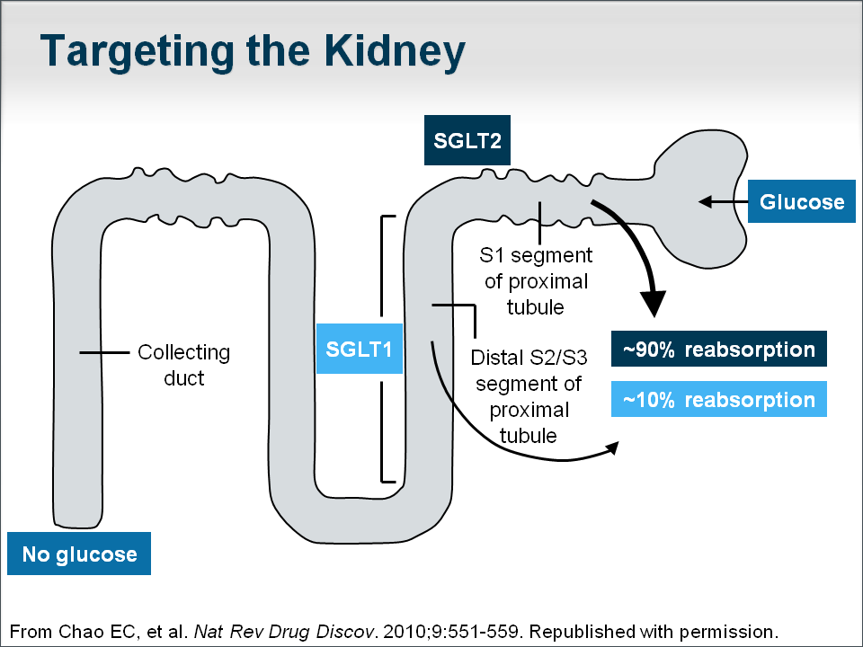
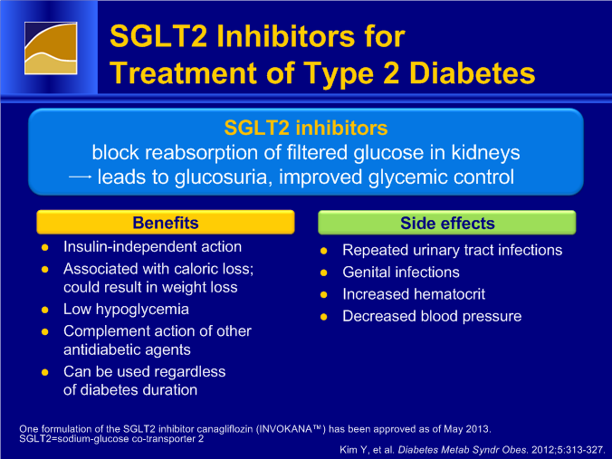

- Main challenge is vaginal yeast infections in women and balanitis in uncircumcised men.

Complications of poorly controlled diabetes mellitus
- Diabetic retinopathy (eye damage leading to blindness).
- Diabetic nephropathy (kidney damage leading to ESKD or kidney failure).
- Diabetic neuropathy (nerve damage leading to numbness & burning sensation in the extremities, nausea, vomiting & constipation, erectile dysfunction).
- Cardiovascular diseases e.g. stroke, angina, atherosclerosis.
- Diabetic foot (foot damage due to decreased blood flow to the foot and neuropathy).
- Short term complications like DKA and HHNKC/HHS.

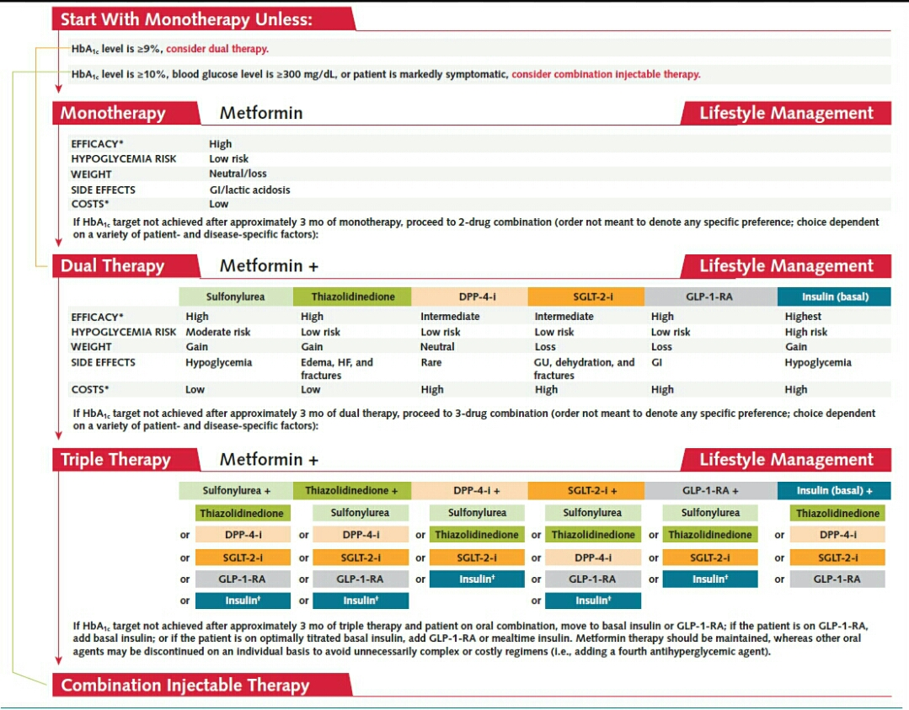

Patient Education.
- Teach patients how to avoid foot injury.
- Hospital occupational therapist should advise patients on foot care.
- Patients with injury however minor should seek medical advice,
- Patients should eat regularly.
- Teach patients on how to pick signs of hyperglycemia and hypoglycemia.
- Patients should carry sweets or glucose and chew them if they experience any symptoms of hypoglycemia.
- Patients should always carry “Diabetic Alert” card with them.
- Patients should join diabetes support groups.

Considerations
- Metformin, if not contraindicated and if tolerated, is the preferred initial pharmacological agent for type 2 diabetes.
- In patients with newly diagnosed type 2 diabetes and markedly symptomatic and/or elevated blood glucose levels or A1C, consider insulin therapy (with or without additional agents)
- If noninsulin monotherapy at maximal tolerated dose does not achieve or maintain the HbA1C target over 3 months, add a second oral agent, a GLP-1 receptor agonist, or insulin.
- Pharmacological therapy for patients with diabetes and hypertension comprise a regimen that includes either an ACE inhibitor or angiotensin II receptor blocker. These agents are renal protective.
- Consider aspirin therapy (75–162 mg/day) as a primary prevention strategy against cardiovascular diseases in elderly patients: men >50 years of age or women >60 years. For those patients with documented aspirin allergy, Clopidogrel (75 mg/day) should be used instead.
- Statin therapy eg Atovastatin, simvastatin, rosuvastatin, pravastatin should be initiated for those patients above 50 years.
- Diabetic peripheral neuropathic pain (a burning, tingling or aching discomfort tjat worsens at night) affects the functionality, mood and sleep patterns of diabetics. It can be managed by anticonvulsants like Carbamazepine or Tricyclic antidepressants like Amitriptyline or even opiates like tramadol or dihydrocodeine.
THE END

